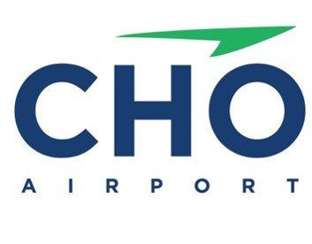

CHARLOTTESVILLE-ALBEMARLE AIRPORT BASIN “C” MAINTENANCE

PUBLIC NOTICE-INTENT TO AWARD-JULY 30, 2024

The Charlottesville-Albemarle Airport Authority (“Authority”) hereby announces its intent to award the invitation to bid for the Basin C Maintenance Project to Pleasant View Developers, Inc.

This award is made pursuant to the Invitation to Bid for the above-described services issued on July 17, 2024. After conducting the ITB process in accordance with the guidelines, the Authority’s Chief Executive Officer has concluded that Pleasant View Developers, Inc. submitted the lowest responsive and responsible bid and will provide the best value for the Authority.

The Authority reserves the right to cancel this Notice of Intent to Award at any time.

This Notice of Intent to Award initiates the ten (10) day period during which an offeror may submit a bid protest in accordance with the applicable provisions of the Virginia Public Procurement Act.

